Develop Total Body Photography Supplement

SUBMITTED BY Liam Caffery

On Behalf of Working Group 19 Dermatology

Introduction/Scope
This work item proposes the development of total body photography (TBP) supplement which includes an information object definition (IOD) for TBP and storage SOP class for TBP images.

Background
TBP aims to image a person’s entire skin service. TBP is predominantly used for sequential screening for skin cancers, in particular melanoma, but can also be used for the assessment of inflammatory skin diseases such as psoriasis. TBP (often used in combination with dermoscopy) has improved the accuracy of skin cancer diagnosis while reducing the number of biopsies of benign skin lesions.

TBP uses visual light imaging. TBP may be 2D or 3D.

2D examinations use a single camera mounted on a frame (Figure 1) and multiple acquisitions are used to obtain coverage of the entire skin surface. 3D devices use multiple cameras housed withing a gantry. 3D examinations can be 360 degree which uses both a forward-facing and rear-facing gantry (Figure 2) or 180 degrees which uses a single gantry system.

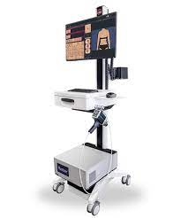
Figure 1. 2D total body photography device (Source: FotoFinder)
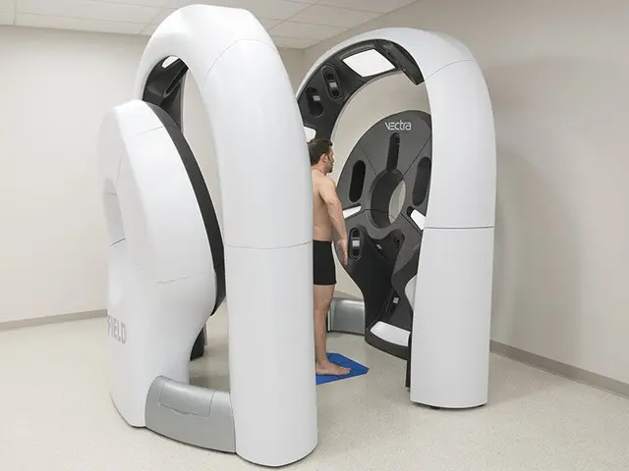
Figure 2. 360-degree 3D total body photography (image source: Canfield Scientific)

Limitations of Current Standard
There is currently no IOD that can be used to record TBP with the standardized metadata required for clinical utility. A TBP IOD would provide advantage over alternative IODs (e.g. VL Photographic, Secondary Capture) by including attributes to describe imaging technique and co-ordinates of skin lesions.

Description of Proposal
We propose to write a DICOM Supplement for TBP. The supplement will define a Total Body Photography Image IOD, define a Total Body Photography Image Storage SOP class, and if required define new DICOM attributes.

Parts of Standard Affected
PS3.3 Information Object Definition
PS3.4 Service Class Specification
PS3.6 Data Dictionary
PS3.16 Content Mapping Resource
PS3.17 Explanatory Information

Resources & Time Line
We currently have eight active members in Working Group 19 including two vendors of TBP devices.
Liam Caffery will edit the supplement. Other member will contribute subject matter expertise.WG-19 will meet by video / teleconference on a monthly basis. It is estimated that the supplement will take about twelve months. A first draft will be available by November 2023.
Members of WG-19 anticipate that four hours of WG-06 meeting time will be required on two occasions during 2023 and 2024 to review and approve an early draft as well as public comment, letter ballot, and final text versions of the supplement.

