Digital Imaging and Communications in Medicine (DICOM)

DICOM Supplement 250: 2D Total Body Photography

Prepared by:

DICOM Standards Committee, Working Group 19
1812 N. Moore St, Suite 2200
Arlington, Virginia 22209 USA
Status: Public Comment, July 2026
Developed pursuit of DICOM Work Item: 2022-12-B

Document History

Open Issues
1. | Should the Photogrammetry Image Calibration module have Conditional usage to promote improved image measurement accuracy and what condition/s must be satisfied for photogrammetry calibration to work reliably?
2. | Do we need to include Image Sensitive Code Sequence (0008,001D) and Recognizable Visual Features (0028,0302) as per recent CP1982?

Closed Issues
1. | For noting only: BCID B=Baseline not restricted. DCID D=Defined restricted.
2. | Should Recognizable Visible Features be a Type 1 Attribute?  A: No, you may not be able to assign value at acquisition. Hence, can’t be Type 1
4. | How is Relative Camera Orientation encoded?  A: Using Viewpoint Position (0070,1603), Viewpoint LookAt Point (0070,1604) and Viewpoint Up Direction (0070, 1604).  Relative Camera Orientation is defined as the relative camera orientation with respect to the first camera. The orientation is represented as a 3x3 rotation matrix, which transforms the subsequent camera after the translation is applied. Viewpoint LookAt Point is defined as The direction in which the camera is pointing using a 3D vector and Viewpoint Up Direction is defined as the direction which is up for the camera using a 3D vector. They are both ways of describing camera orientation.
8. | Do we need attribute “First Camera as Reference”?  A: No.  By using "Viewpoint Position", "Viewpoint LookAt Point", and "Viewpoint Up Direction", they should be defined in a common space shared by all image acquisitions (not relative to another camera).
5. | Are pinhole cameras or anamorphic lens used in any TBP systems?  A: Yes.  TBP systems [1,2,3] may use pinhole cameras. Having the Horizontal and Vertical Focal Length attributes is standard practice in intrinsic camera parameters for camera calibration.  [1] Korotkov, Konstantin, et al. "A new total body scanning system for automatic change detection in multiple pigmented skin lesions." IEEE transactions on medical imaging 34.1 (2014): 317-338.  [2] Ahmedt-Aristizabal, David, et al. "Monitoring of pigmented skin lesions using 3D whole body imaging." Computer Methods and Programs in Biomedicine 232 (2023): 107451.  [3] Huang, Wei-Lun, et al. "A Shape-Aware Total Body Photography System for In-focus Surface Coverage Optimization." IEEE Journal of Biomedical and Health Informatics (2025).
6. | Do we need a focus breathing attribute?  A: Yes Focus breathing is a geometric change in the camera’s field of view during focusing. If a camera captures multiple images at different focus distances, Focus Breathing is a flag to indicate whether the camera's intrinsic parameters (e.g., focal length) should be different for various focus distances.
7. | The depth of field of a camera in TBP may preclude all the patient’s skin surface being in focus. To this end, this supplement introduces a new attribute Focal Distance which is defined as “Distance, in meters, from the image plane to the focal plane (where the image is sharply focused).” Focal Distance is not to be confused with Focal Length – which is a lens property (e.g., 50mm). NB. There is currently no “Focal Distance” defined in EXIF or DICOM.  Could we use the existing attribute Subject Distance (0016,0026) instead of Focal Distance? Or are there other alternatives?  A: Use Subject Distance (0016,0026) which is defined as "The distance to the subject in meters." The existing Subject Distance may be suitable because it usually refers to the same concept that measures the distance from the focal plane to the subject (where the subject is in focus).
8. | For TBP should modality be XC (external camera) or TBP (total body photography)?  A: Use TBP as it would allow people to search via modality to get TBP, whereas XC would include imaging beyond TBP.
9. | Is color calibration used?  A: Yes, ICC profiles may be used but not by all vendors

Table of Contents
Scope and Field of Application 7
Changes to NEMA Standards Publication PS 3.2 8
Part 2: Conformance 8
Changes to NEMA Standards Publication PS 3.3 9
Part 3: Information Object Definitions 9
2 Normative References 9
2.6 Other References 9
A.X.X TBP Regional Image IOD 9
A.X.X.1 TBP Regional Image IOD Description 9
A.X.X.2 TBP Regional Image IOD Description Entity-Relationship Model 9
A.X.X.3 TBP Regional Image IOD Module Table 9
A.X.X.4 TBP Regional Image IOD Content Constraints 11
C.7.3.1.1 General Series Attribute Descriptions 11
C.7.3.1.1.1 Modality 11
C.8.12 VL Modules and Functional Group Macros 11
C.8.12.1 VL Image Module 11
C.8.12.11 VL Photographic Acquisition Module 12
C.8.X.X TBP Regional Image Module 13
C.8.X.Y Photogrammetry Calibration Module 14
Changes to NEMA Standards Publication PS 3.6 16
Part 6: Data Dictionary 16
Changes to NEMA Standards Publication PS 3.16 17
Part 16 Content Mapping Resource 17
Changes to NEMA Standards Publication PS 3.17 18
Part 17: Explanatory Information 18
Annex XXXX 2D Total Body Photography (Informative) 18
XXXX.1 Basic Structured Display IOD for visualization of images within a 2D TBP imaging examination 18
XXXX.2 Series Organization 20
XXXX.3 Frame of Reference 20
XXXX.4 Camera Coordinate System 20
XXXX.5 Use of Photogrammetry Calibration Module 22
XXXX.6 TBP Regional Image Storage 24

Scope and Field of Application
This supplement introduces Total Body Photography (TBP) Regional Image Information Object Definition (IOD) for imaging of a skin region.

TBP images a person’s entire skin surface. TBP is predominantly used for periodic sequential screening for skin cancer, in particular melanoma, but can also be used for the assessment of inflammatory skin diseases such as psoriasis.
TBP may be 2D or 3D. This supplement addresses 2D TBP which produces 2D planar images, whereas 3D TBP produces volumetric images.
TBP uses visible light imaging. Camera movement may be manual or automatic. There are typically multiple image acquisitions with the patient in different positions. Multiple regional images are acquired to image entire skin surface. TBP is often used in combination with dermoscopy.

Changes to NEMA Standards Publication PS 3.2
Digital Imaging and Communications in Medicine (DICOM)

Part 2: Conformance
Add new SOP Classes in Table A.1-2

The SOP Classes are categorized as follows:
Table A.1-2 UID Values
UID Value | UID Name | Category
…
1.2.840.10008.5.1.4.1.1.1 | Computed Radiography Image Storage SOP Class | Transfer
1.2.840.10008.5.1.4.1.1.77.1.4 | VL Photographic Image Storage SOP Class | Transfer
1.2.840.10008.xxxx | TBP Regional Image IOD | Transfer
…

Changes to NEMA Standards Publication PS 3.3
Digital Imaging and Communications in Medicine (DICOM)

Part 3: Information Object Definitions

Amend PS3.3 Section A.1.4 Overview of the Composite IOD Module Content to include new IODs.

Add to PS3.3

2 Normative References

2.6 Other References
[Hartley and Zisserman 2003] Hartley, Richard and Zisserman, Andrew. Multiple View Geometry in Computer Vision. 2nd Ed. 2003. Cambridge University Press. https://doi.org/10.1017/CBO9780511811685

A.X.X TBP Regional Image IOD

A.X.X.1 TBP Regional Image IOD Description
The Total Body Photography (TBP) Regional Image IOD specifies images that are acquired using visible light imaging. TBP regional images are acquired of a region of the skin surface. Multiple regional images are acquired during a TBP skin examination for coverage of the entire skin surface. Each regional image is stored as a SOP instance.
The TBP Regional Image Information Object Definition (IOD) is an extension of the existing Visible Light (VL) Photographic Image IOD.

A.X.X.2 TBP Regional Image IOD Description Entity-Relationship Model
The TBP Regional Image IOD uses the DICOM Composite IOD Entity-Relationship Information Model defined in Section A1.2, with only the Image IE below the Series IE.

A.X.X.3 TBP Regional Image IOD Module Table
Table A.X.X.3-1 TBP REGIONAL IMAGE IOD MODULES
IE | Module | Reference | Usage
Patient | Patient | C.7.1.1 | M
Patient | Clinical Trial Subject | C.7.1.3 | U
Study | General Study | C.7.2.1 | M
Study | Patient Study | C.7.2.2 | U
Study | Clinical Trial Study | C.7.2.3 | U
Series | General Series | C.7.3.1 | M
Series | Clinical Trial Series | C.7.3.2 | U
Frame of Reference | Frame of Reference | C.7.4.1 | U
Equipment | General Equipment | C.7.5.1 | M
Equipment | Enhanced General Equipment | C.7.5.2 | M
Equipment | VL Photographic Equipment | C.8.12.10 | U
Acquisition | General Acquisition | C.7.10.1 | M
Image | General Image | C.7.6.1 | M
Image | General Reference | C.12.4 | U
Image | Image Pixel | C.7.6.3 | M
Image | Image Plane | C.7.6.2 | U
Image | Patient Orientation | C.7.6.20 | U
Image | VL Image | C.8.12.1 | M
Image | VL Photographic Acquisition | C.8.12.11 | U
Image | TBP Regional Image | C.8.X.X | M
Image | Photogrammetry Calibration | C.8.X.Y | U
Image | Acquisition Context | C.7.6.14 | U
Image | ICC Profile | C.11.15 | U
Image | SOP Common | C.12.1 | M
Image | Common Instance Reference | C.12.2 | U

A.X.X.4 TBP Regional Image IOD Content Constraints

A.X.X.4.1 Modality
The value of Modality (0008,0060) shall be TBP.

A.X.X.4.2 Acquisition Context Module
The Defined TID for Acquisition Context Sequence (0040,0555) is TID 8300 “Skin Imaging Acquisition Context”.

A.X.X.4.3 Anatomic Region Sequence
For Anatomic Region Sequence (0008,2218) BCID 4029 “Dermatology Anatomic Site” may be used.​ For Anatomic Region Modifier Sequence (0008,2220) BCID 245 “Laterality with Median” may be used.
Add to PS3.3 C.7.3.1.1.1 Modality

C.7.3.1.1 General Series Attribute Descriptions

C.7.3.1.1.1 Modality

Defined Terms:
…
- TBP Total Body Photography
…

C.8.12 VL Modules and Functional Group Macros
Modify PS3.3 C.8 Modality Specific Modules

C.8.12.1 VL Image Module
Table C.8-77 specifies the Attributes that describe a VL Image produced by Endoscopy (ES), General Microscopy (GM), Automated-Stage Microscopy (SM), External-camera Photography (XC), Dermoscopy (DMS), Total Body Photography (TBP), or other VL imaging Modalities.

C.8.12.11 VL Photographic Acquisition Module
Table C.8.12.11-1. VL Photographic Acquisition Module Attributes
Attribute Name | Tag | Type | Attribute Description
….
Camera Elevation Angle | (0016,0035) | 3 | The elevation/depression (angle of the orientation of the camera, imaging optical axis) in degrees from -180 to less than 180, at the time of acquisition.
Focal Length | (0016,0029) | 3 | The actual focal length of the lens, in mm.
Subject Distance | (0016,0026) | 3 | The distance to the subject in meters.

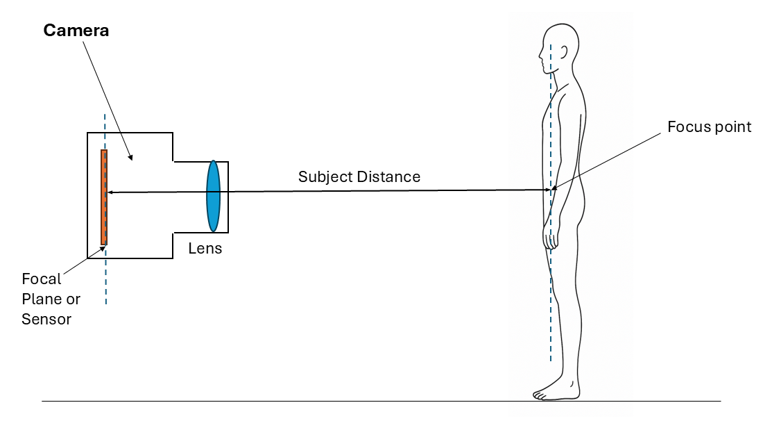
Figure C.8.12.11-1 Subject Distance
Add the following new subsection in PS3.3 C.8

C.8.X.X TBP Regional Image Module
Table C.8.X.X-1 specifies the Attributes that describe TBP regional images.
Table C.8.X.X-1. TBP Regional Image Module Attributes
Attribute Name | Tag | Type | Attribute Description
Recognizable Visual Features | (0028,0302) | 2 | Indicates whether or not the image contains sufficiently recognizable visual features to allow the image or a reconstruction from a set of images to identify the Patient.  Enumerated Values:  YES  NO
Light Source Polarization | (0016,1001) | 2 | Polarization of the camera light source.  Enumerated Values:  POLARIZED  NON_POLARIZED

C.8.X.Y Photogrammetry Calibration Module
Table C.8.X.Y-1 specifies the attributes used for photogrammetry spatial calibration. The attributes are harmonized with Multiple View Geometry in Computer Vision [Hartley and Zisserman 2003]. The attributes for lens distortion are based on the widely used Brown–Conrady model, which is commonly adopted in the computer vision community, including in the OpenCV library (openCV.org), and is also described in the Hartley and Zisserman text.
Table C8.X.Y-1 Photogrammetry Calibration Module Attributes
Attribute | Tag | Type | Attribute Description
Photogrammetric Calibration Sequence | (ggg1,eee1) | 1 | Describes a camera (a lens and its connected sensor).  One or more items shall be present. One item corresponds to the calibration of one camera.
>Horizontal and Vertical Focal Length | (ggg1,eee2) | 2 | Horizontal focal length Fx followed by the vertical focal length Fy in pixel units as defined by the underlying camera model (e.g., CCD cameras that could have non-square pixels).
>Principal Point Coordinates | (ggg1,eee3) | 2 | The intersection of the optical axis through the image plane. Values are stored as pixel coordinates Cx followed by Cy.
>Radial Lens Distortion | (ggg1,eee4) | 2 | Characterization of radial distortion of the camera lens which causes real world straight lines to appear curved lines in an image. Expressed as three radial distortion coefficients in the order k1, k2, k3 where 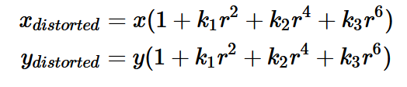  (x, y) = undistorted image coordinates  r = radius as Euclidean distance to image center
>Tangential Lens Distortion | (ggg1,eee5) | 2 | Characterization of tangential distortion caused by misalignment of the lens and images sensor resulting in images shifting tangentially (sideways). Expressed as two values, p1 followed by p2, which describe the magnitude and direction of tangential distortion respectively.  The resulting x and y distortion can be calculated using the following equations.  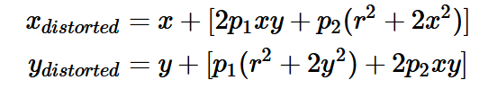  (x, y) = undistorted image coordinates  r = radius as Euclidean distance to image center
>Viewpoint Position | (0070,1603) | 2 | The position of the camera defined using a point (x,y,z).
>Viewpoint LookAt Point | (0070,1604) | 2 | The point (x,y,z) the camera is looking at.
>Viewpoint Up Direction | (0070,1605) | 2 | Vertical orientation of the camera. Expressed as a vector (x,y,z).
>Focus Breathing | (ggg1,eee6) | 3 | Whether a geometric change in field-of-view occurs when changing the focus distance of the lens.  Enumerated Values:  YES  NO

Changes to NEMA Standards Publication PS 3.6
Digital Imaging and Communications in Medicine (DICOM)

Part 6: Data Dictionary
Add to PS3.6 Annex A

UID Value | UID NAME | UID TYPE | Part
1.2.840.10008.xxx | TBP Regional Image IOD | SOP Class | PS3.4

Add to PS3.6 the following Data Elements to Section 6, Registry of DICOM data elements:

Tag | Name | Keyword | VR | VM
(ggg1,eee1) | Photogrammetric Lens Sequence | PhotogrammetricLensSequence | SQ | 1-n
(ggg1,eee2) | Horizontal and Vertical Focal Length | HorizontalandVerticalFocal Length | FL | 2
(ggg1,eee3) | Principal Point Coordinates | PrincipalPointCoordinates | FL | 2
(ggg1,eee4) | Radial Lens Distortion | RadialLensDistortion | FL | 3
(ggg1,eee5) | Tangential Lens Distortion | TangentialLensDistortion | FL | 2
(ggg1,eee6) | Focus Breathing | FocusBreathing | CS | 1

Changes to NEMA Standards Publication PS 3.16
Digital Imaging and Communications in Medicine (DICOM)

Part 16 Content Mapping Resource

Modify tables in PS3.16 Annex B

CID 29 Acquisition Modality
Resources: HTML | FHIR JSON | FHIR XML | IHE SVS XML
Type: Extensible
Version:
UID: 1.2.840.10008.6.1.19
Table CID 29. Acquisition Modality
Coding Scheme Designator | Code Value | Code Meaning
…
DCM | TBP | Total Body Photography
…

Changes to NEMA Standards Publication PS 3.17
Digital Imaging and Communications in Medicine (DICOM)

Part 17: Explanatory Information
Add to PS3.17 Annex XXXX

Annex XXXX 2D Total Body Photography (Informative)

XXXX.1 Basic Structured Display IOD for visualization of images within a 2D TBP imaging examination
TBP regional images within a 2D TBP imaging examination are typically displayed in a matrix format which each patient position (e.g. anterior, right side, posterior left side) displayed as a column and each acquisition position displayed as a row (See Figure XXXX.1-1). A Basic Structured Display IOD may be used to encode a specific layout and intended display of images within a TBP study. The 2D TBP imaging device might produce the structured image display object, or it might be produced by a third-party application. The Basic Structured Display IOD is limited to display on a single screen
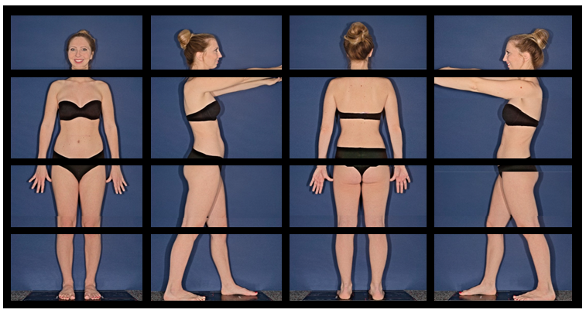
Figure XXXX.1-1 Display of 2D TBP imaging study

Figure XXXX.1-2 is a graphical representation of the Structured Display Image Box module.

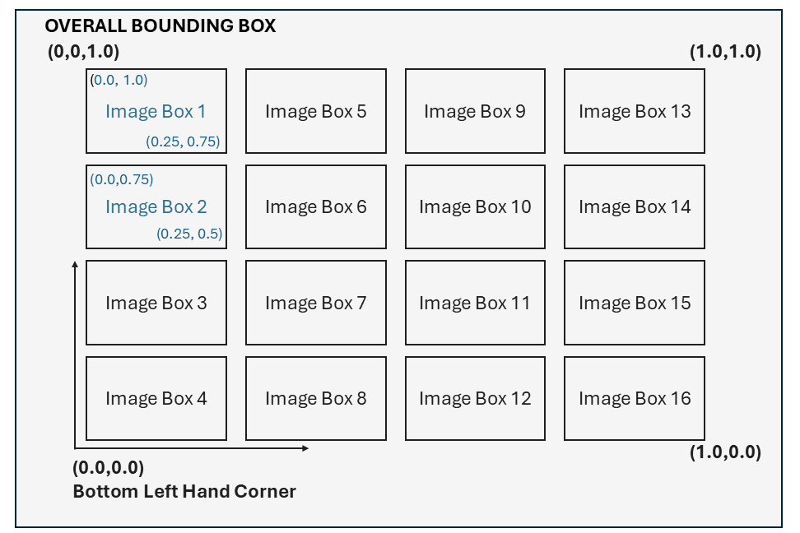
Figure XXXX.1-2 Representation of a Structured Display Image Box used to display
Table XXXX.1-1 is an example encoding of the Structured Display Image Box (Figure XXXX.1-2). Image annotations via referenced Presentation State objects and simple text labels on the screen, e.g., for image box labeling or study identification can also be encoded using the Basic Structured Display IOD.
Table XXXX.1-1 Example encoding of the Structured Display Image Box
Structured Display Image Box Sequence (0072,0422)
#Image Box 1
> Display Environmental Spatial Position (0072,0108): 0.0\1.0\0.33\0.75
> Image Box Number (0072,0302): 1
> Image Box Layout Type (0072,0304): TILED
> Image Box Tile Horizontal Dimension (0072,0306): 4000
> Image Box Tile Vertical Dimension (0072,0308): 3000
> Referenced Image Sequence (0008,1140)
>> Reference SOP Class UID (0008,1150): 1.2.840.10008.x.x.x.x
>> Reference SOP Instance UID (0008,1155): 1.2.3.450.789.2212234577

#Image Box 2
> Display Environmental Spatial Position (0072,0108): 0.0\0.75\0.33\0.5
> Image Box Number (0072,0302): 2
> Image Box Layout Type (0072,0304): TILED
> Image Box Tile Horizontal Dimension (0072,0306): 4000
> Image Box Tile Vertical Dimension (0072,0308): 3000
> Referenced Image Sequence (0008,1140)
>> Reference SOP Class UID (0008,1150): 1.2.840.10008.x.x.x.x
>> Reference SOP Instance UID (0008,1155): 1.2.3.450.789.222369874
>Referenced Presentation State Sequence (0008,9237)
>> Reference SOP Class UID (0008,1150): 1.2.840.10008.x.x.x.x
>> Reference SOP Instance UID (0008,1155): 1.2.3.450.789.222369874
…

XXXX.2 Series Organization
In terms of how images are organized into series, the following is recommended:
- All regional images acquired in one anatomical position (e.g. anterior, posterior, right lateral, left lateral) with respect to the camera as part of 2D TBP imaging examination are encoded in same series.
- Each anatomical position is encoded in a separate series.
- Dermoscopic or Visible Light macroscopic images within the imaging study are in a different series to the regional images.

XXXX.3 Frame of Reference
DICOM requires that all images in a Series that share the same Frame of Reference UID are spatially related to each other. A Frame of Reference ensures a consistent spatial coordinate system that allows images to be combined, overlaid, registered, or stitched. The Frame of Reference Module may be used when multiple, successive images are acquired with the patient in a single anatomical position. Images are acquired using a controlled and reproducible spatial setup (i.e., not using a handheld camera). Successive images acquired under these conditions are spatially related and are encoded within the same Series with a shared unique Frame of Reference.

XXXX.4 Camera Coordinate System
The Viewpoint Position (0070,1603), Viewpoint LookAt Point (0070,1603), and Viewpoint Up Direction (0070,1603) are defined in a common reference coordinate system shared by all image acquisitions during an imaging examination.
The camera coordinate system is a right-hand coordinate system (RHCS) consisting of x, y, and z axes originating at the Viewpoint Position. The x-axis points to the right, the y-axis points down, and the z-axis points forward, in the direction the camera is looking. Therefore, the z-axis aligns with the Viewpoint LookAt Point (0070,1603), and the y-axis aligns with the opposite of the Viewpoint Up Direction (0070,1603). See Figure XXXX4-1.
The difference in camera coordinate system definition is a convention issue between computer vision versus computer graphics. Both are defined in the right-handed Cartesian system. We have used the computer vision convention.
For each image acquisition, a point (X_{C}, Y_{C}, Z_{C}) with respect to its camera coordinate system can be transformed into (X_{R}, Y_{R}, Z_{R}) with respect to the common reference coordinate system by a rigid transformation below.
$$\left[\begin{matrix}X_{R} \\ Y_{R} \\ Z_{R} \\ 1\end{matrix}\right] = \left[\begin{matrix}R_{XX} & R_{YX} & R_{ZX} & T_{X} \\ R_{XY} & R_{YY} & R_{ZY} & T_{Y} \\ R_{XZ} & R_{YZ} & R_{ZZ} & T_{Z} \\ 0 & 0 & 0 & 1\end{matrix}\right] \left[\begin{matrix}X_{C} \\ Y_{C} \\ Z_{C} \\ 1\end{matrix}\right]$$
Where:
R_{ij}, R_{ij}, R_{ij} A 3x3 rotation matrix. The first column [R_{XX}, R_{XY}, R_{XZ}] are the direction cosines (projection) of the x-axis of the camera coordinate system with respect to the common reference coordinate system. The second column [R_{YX}, R_{YY}, R_{YZ}] are the direction cosines (projection) of the y-axis of the camera coordinate system with respect to the common reference coordinate system (i.e., the opposite of the (normalised) Viewpoint Up Direction (0070,1603)). The third column [R_{ZX}, R_{ZY}, R_{ZZ}] are the direction cosines (projection) of the z-axis of the camera coordinate system with respect to the common reference coordinate system (i.e., the unit vector from the Viewpoint Position (0070,1603) toward the Viewpoint LookAt Point (0070,1603)).
T_{X}, T_{Y}, T_{Z} The origin of the camera coordinate system with respect to the common reference coordinate system (i.e., the Viewpoint Position (0070,1603)).
The choice of common reference coordinate system is vendor specific. For simplicity, one example could be using the first image acquisition as the reference coordinate system. In this case, for the first image acquisition, the Viewpoint Position is (0,0,0), the Viewpoint Up Direction is (0,-1,0), and the Viewpoint LookAt Point is an arbitrary point on the ray from (0,0,0) along the direction (0,0,1).

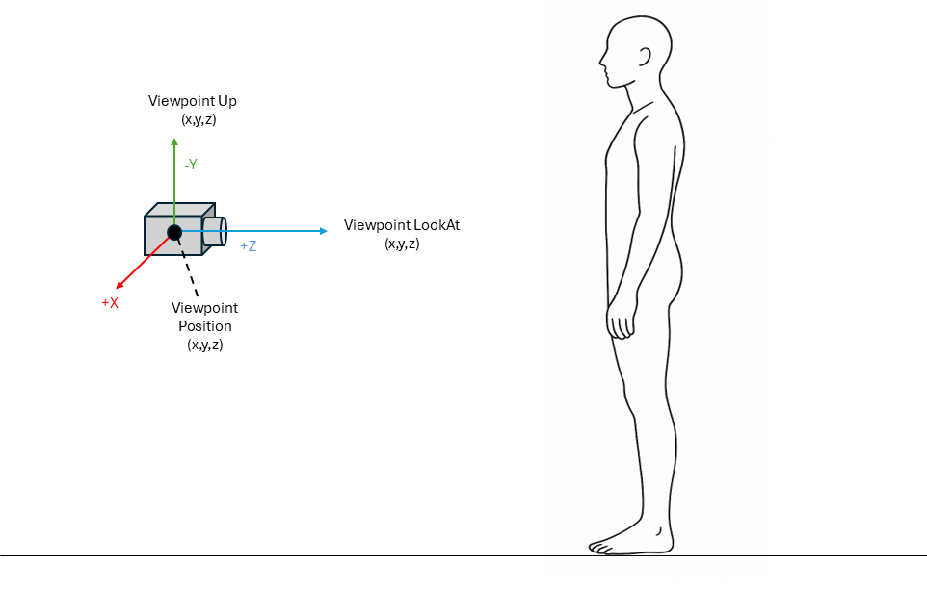

Figure XXXX.4-1 Camera coordinates

XXXX.5 Use of Photogrammetry Calibration Module
Photogrammetry calibration data describing the lens and image path can be used for 1) multi-view lesion correspondence and 2) lesion size measurements.

Multi-view lesion correspondence
The same lesion may appear in multiple 2D TBP regional images acquired during one patient visit. This is more pronounced in TBP systems employing multi-axis cameras, where overlapping fields of view increase the likelihood of capturing the same lesion in multiple images. Establishing correspondence of lesions across these images is important for subsequent whole-body skin lesion analysis, rather than treating duplicate observations as independent lesions. For example, Epipolar geometry from photogrammetry calibration can be used as follows (see Figure XXXX-5-1):
- Detect lesions in each 2D TBP regional image.
- For each detected lesion determine the lesion image point (i.e., 2D pixel coordinate of the centre of the lesion).
- Use Radial Lens Distortion (ggg1, eee4) and Tangential Lens Distortion (ggg1,eee5) to undistort the lesion image point.
- Select a lesion in selected image (image A).
- Conduct a search for the same lesion in each other image (image B).
- Apply epipolar constraint to reduce the search area from the entire image B to a single line (or a narrow band, accounting for slight errors and noise). For a lesion ($L_{A}$) in image A, the possible location it appears on image B can be constrained to a 2D line (the epipolar line). The epipolar line ($l_{B}$) is computed as follows:
$$l_{B}=F L_{A}$$
Where the fundamental matrix (F) is as follows:
$$F={K_{B}}^{-T} {\left[t_{rel}\right]}_{×} R_{rel} {K_{A}}^{-1} \\ K_{A}$$ and $K_{B}$ are the camera intrinsic matrix of image A and image B, constructed by their individual Horizontal and Vertical Focal Length (ggg1,eee2) and Principal Point Coordinates (ggg1,eee3).
$R_{rel}$ and $t_{rel}$ are the relative rotation matrix and the relative translation vector using the Viewpoint Position (0070,1603), Viewpoint LookAt Point (0070,1603), and Viewpoint Up Direction (0070,1603) of image A and image B.
${\left[t_{rel}\right]}_{×}$ is the skew-symmetric matrix form of the translation vector $t_{rel}$.
More details can be found in Chapter 9. Epipolar Geometry and the Fundamental Matrix in Hartley and Zisserman’s Multiple View Geometry in Computer Vision [Hartley and Zisserman 2003].
- Since potential candidates appear on the epipolar line, compute an appearance similarity score only for detected lesions that pass the epipolar line. Then the lesion ($L_{B}$) with the highest score on image B is the corresponding lesion of the query lesion ($L_{A}$) on image A. A detected lesion that fails the epipolar constraint is an invalid candidate.
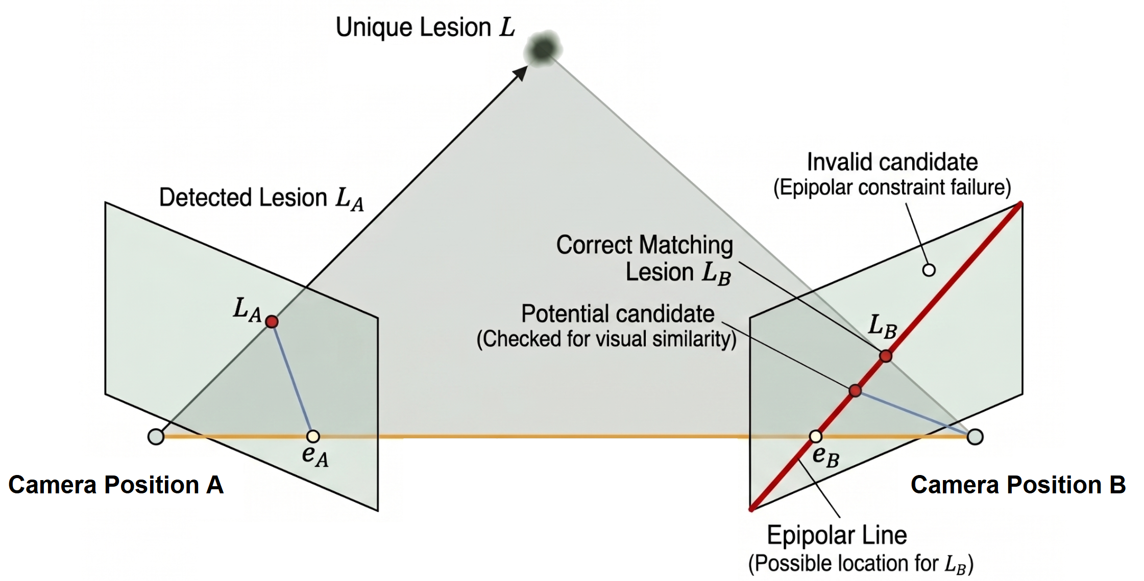

Figure XXXX.5-1 Epipolar geometry for finding multi-view lesion correspondence

Lesion size measurements
Lesion size measurement is dependent on how the contour of a lesion is represented on a 2D TBP regional image. A vendor may choose a circle, a bounding box, or a segmentation of the lesion boundary. Given a lesion and its contour, the size measurement may be done as a linear measurement with a single acquisition or as a measurement in 3D space after reconstructing the 3D coordinates of the lesion contour from multiple image acquisitions. Both cases require undistorting image coordinates using the Radial Lens Distortion (ggg1,eee4) and Tangential Lens Distortion (ggg1,eee5) to remove the lens warping that would otherwise misplace the contour.
For linear measurement with a single image, if the depth value of the image center is known and assuming the plane of the lesion is parallel to the image plane, the size of a lesion in pixels can be converted to millimetres as a linear measurement using the Horizontal and Vertical Focal Length (ggg1,eee2) and Principal Point Coordinates (ggg1,eee3). A clinician manually identifies and selects specific points in the image for measurement.
For a measurement in 3D space, the 3D coordinates of the lesion contour may be reconstructed as follows:
- Each undistorted pixel coordinate of the lesion contour is back-projected into a ray using the Horizontal and Vertical Focal Length (ggg1,eee2) and Principal Point Coordinates (ggg1,eee3) to convert from pixel coordinates to a normalised direction with respect to the camera coordinate system.
- For each ray (starting from the origin of the camera coordinate system), transform it to a ray with respect to the common reference coordinate system by a rigid transformation described in XXXX.4.
- Triangulate rays from all images observing the same boundary point (e.g., applying Least-squares Direct Linear Transformation).
- Measure the lesion size in 3D space once all boundary points are triangulated. The lesion size measurement can be expressed in millimetres because the common reference coordinate system is expressed in physical units.

XXXX.6 TBP Regional Image Storage
It is recommended that TBP regional images be stored as separate SOP instances to support accurate photogrammetry and to preserve acquisition attributes (e.g., camera position). Stitched images may also be stored for visualization purposes; however, this should not replace the individual SOP instances.

